HTML Fundamentals

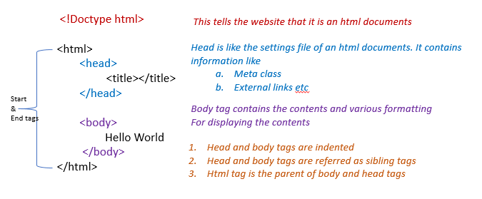

1. **Header** Tags – h1 through h6 - <h1>My Website</h1>
2. **Paragraph** There could be any number of paragraphs
3. **Subscript** - <p>H<sub>2</sub>O</p>
4. **Superscript** - <p>10<sup>2</sup></p>
5. Make certain value or word **small** – <small>This</small>
6. Make certain value or word **big** – <big>This</big>
7. Make certain value or word **bold** - <b>paragraph1</b>
8. **Italicize** a word or value - <i>paragraph1</i>
9. Add **space between** paragraphs <br/><br/>
10. **Horizontal rule** tag (draws a line from left to the right of page) <hr/><hr/>
11. Provide a **link** **to external website**, *other .html pages, images etc.*

* **<a href** = "https://www.google.com"**><h1>**Google Homepage**</h1></a>**

1. **Insert** **image**; src – could be a link or an image saved in the same or different folder; the resolution can be specified (or width & height be specified.). Alt is a backup or description of the image; in case the image is accidentally deleted etc…

* <img **width ="100"** src ="python.png" alt ="This is pythons Logo "/>

1. **Add** **image** (poster- the first look/image; autoplay – so the video starts to play automatically)

* <video src = “tutorial.mp4 controls autoplay poster=”thumb.jpg” width =”300”</video>

1. **Table** **Tags**

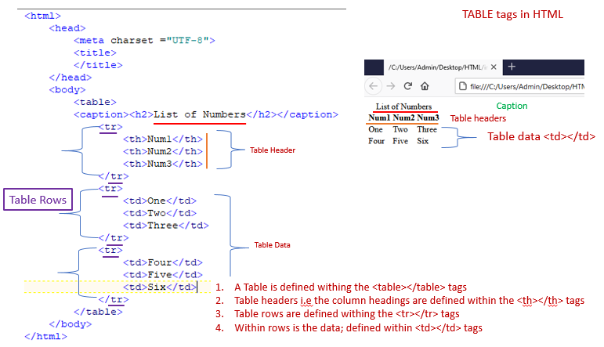

1. **Lists**

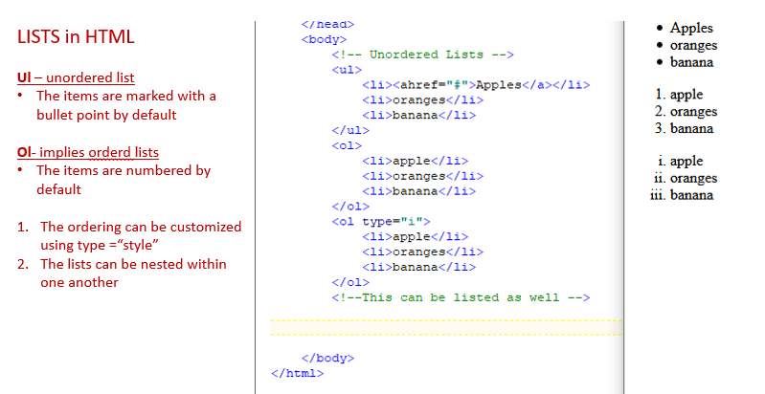

1. **Div & Spans** can be considered as container or wrapper tags in HTML.
   1. Div is a container for block elements
      1. Block elements take entire space width wise and cannot be placed next to one another.
   2. Span is a container for inline Elements
      1. Inline elements take as much space as required and can be placed next to one another
2. **Input and Forms**- Input (radio button/checkbox/text box) are used to accept input from a user.

